**FixMissingMSI Version 2.0 Readme**

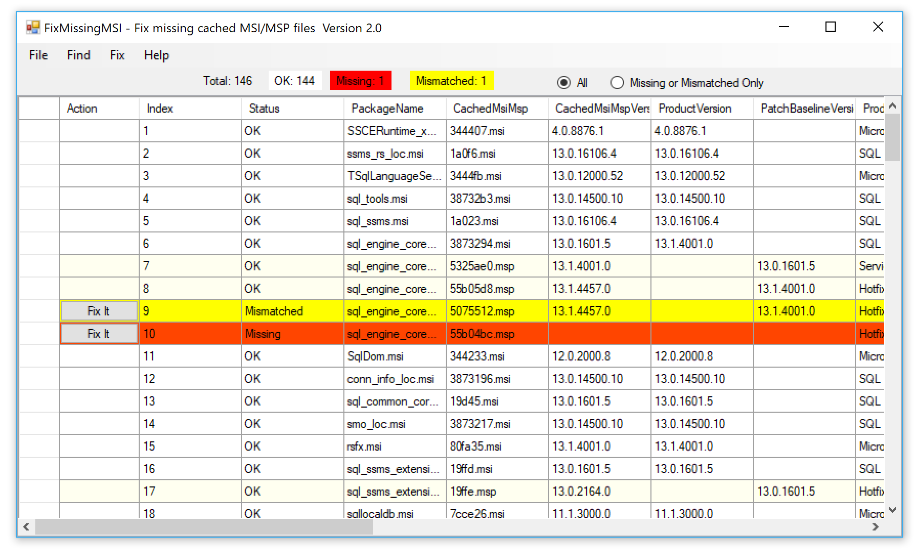

1.

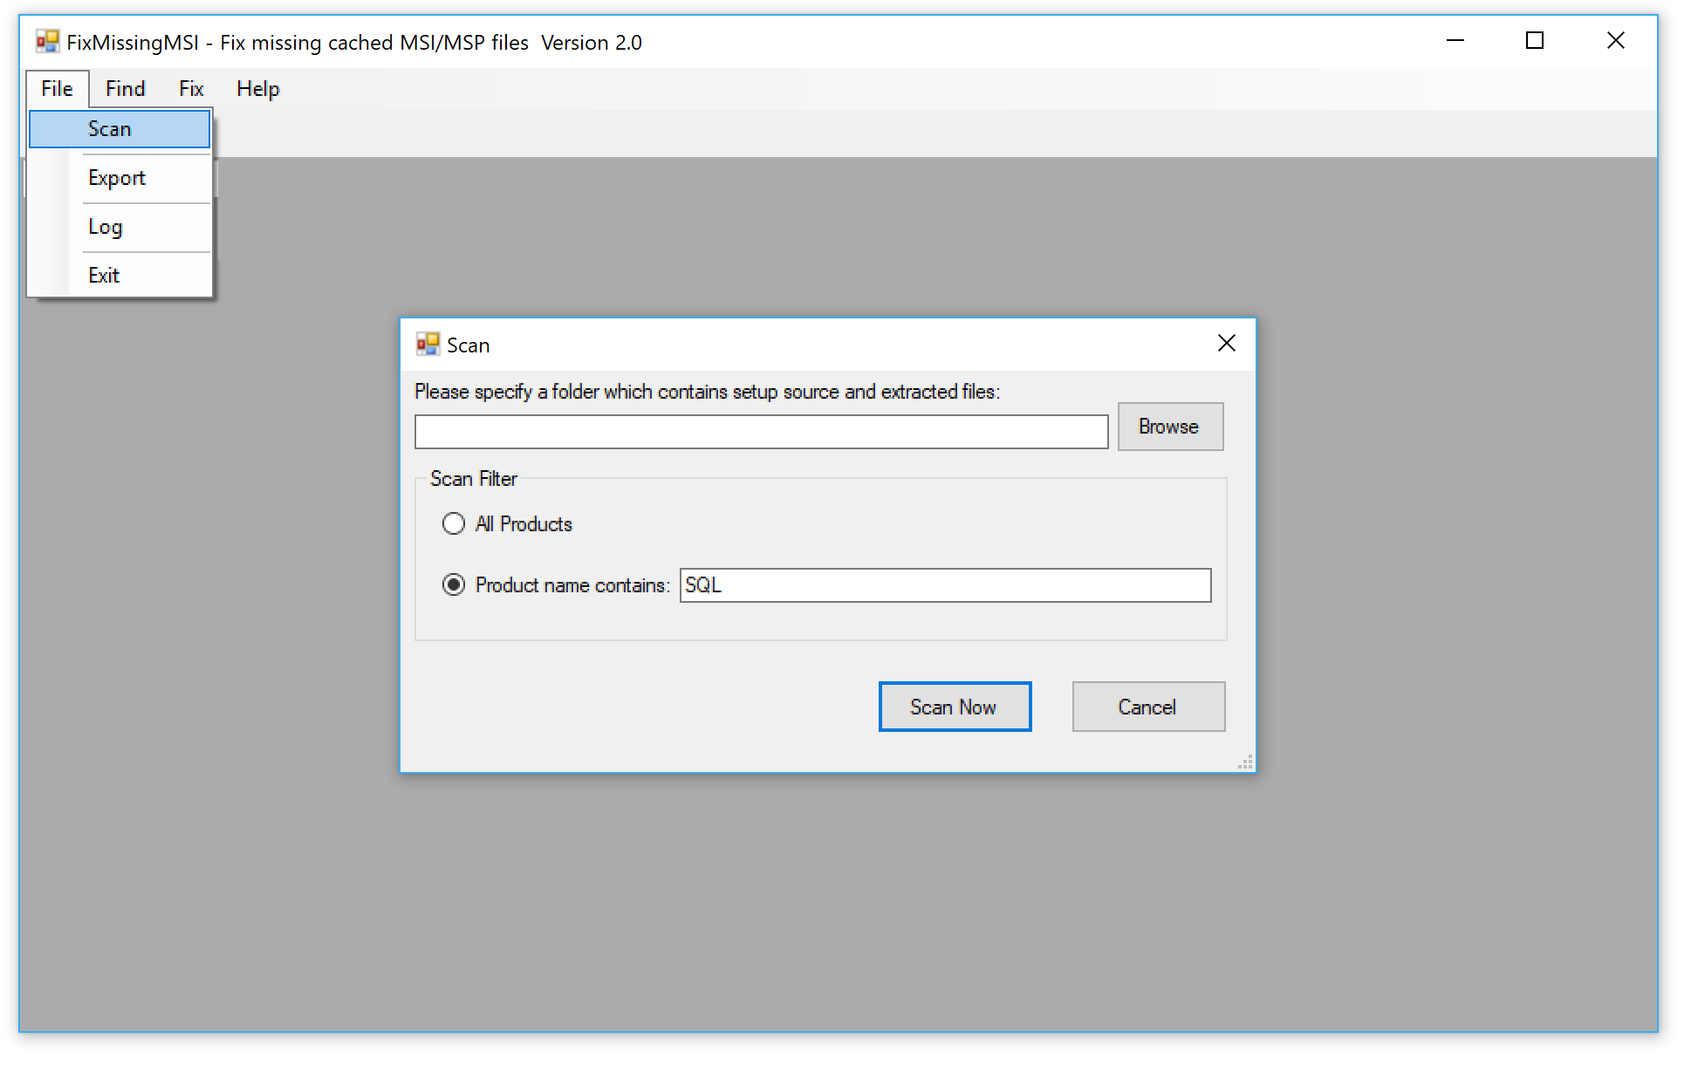

<>Scan menu will popup scan dialog

<>If you choose “Product name contains” and input something like “SQL”, the tool will scan all products where its product name contains the specified key word.

<>If you specify this setup source folder, this tool will scan all those *.MSI and *.MSP files inside, and will check whether any missing/mismatched MSI/MSP can be found from these files.

If you don’t specify this folder this tool may fail to find the MSI/MSP for those missing/mismatched files and hence you are not able to fix them. For some cases although you don’t input this folder but this tool can still be able to find the missing MSI/MSP from its LastUsedSource folder of the installed product.

The best practice, for example, for SQL product, is that you put SQL server RTM setup media and all subsequent service packs, CUs to the same folder, for example:

C:\SQLMedia\RTM

C:\SQLMedia\SP1

C:\SQLMedia\SP1CU1

…

If you download service packs or CUs from the website, please remember to extract its package using X switch to the folder. For example, below command extract SP1 to SP1 subfolder:

SQLServer2016SP1-KB3182545-x64-ENU.exe /X

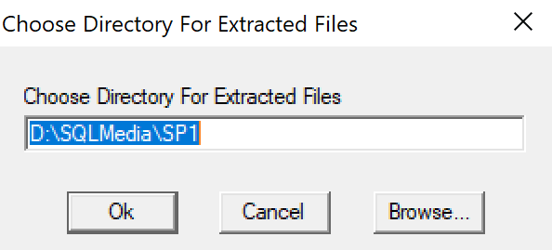

If you don’t extract the package it is not helpful even if the package is in the same folder.

2.



**OK** means cached MSI/MSP exists and their product version matched.

**Missing** means the cached MSI/MSP files are missing.

**Mismatched** means cached file are there but their product name or version are not matched with the expected values.

All: list all rows

Missing or Mismatched only: will list only those missing/mismatched rows.

3.

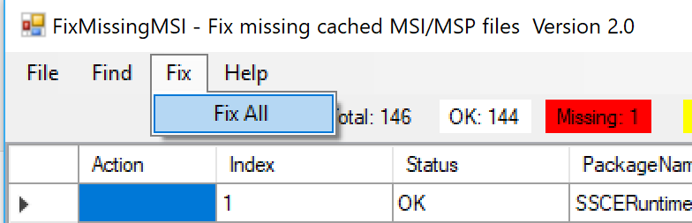

Fix all missing/mismatched automatically. However if expected MSI/MSP file is not found from setup source folder or lastUserSource the fix will fail.

4.

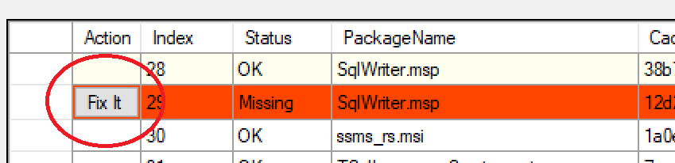

“Fix It” Action will try to fix the missing MSI/MSP for this item.

5.

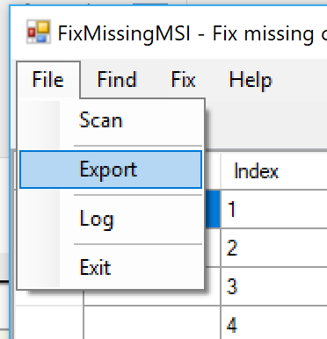

Export menu will save the rows to txt file and csv file. Txt file is readable and csv file can be viewed in excel.

Note: for txt file, better open it with Notepad++ or UltraEdit. It is not readable in notepad.exe.

Log menu to show the run time log of the tool. If any error thrown it will be save in the log.

Readable txt:

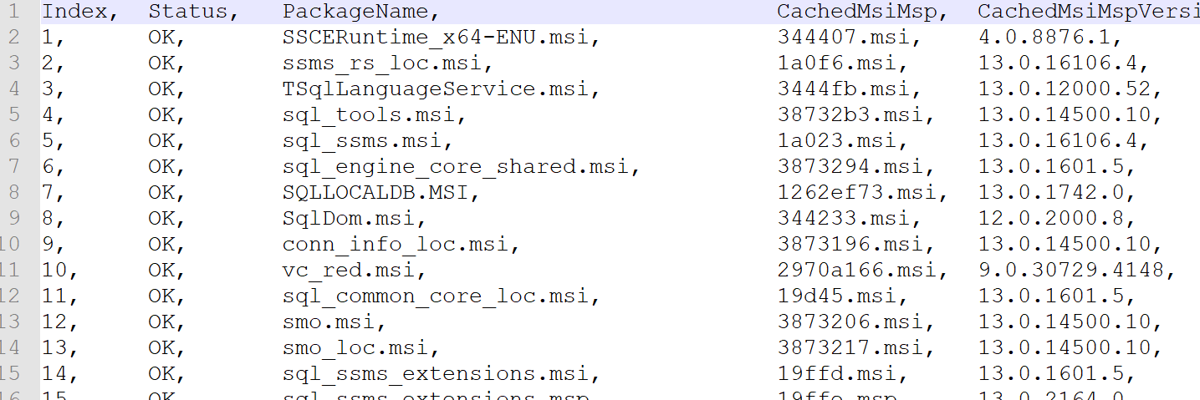

Csv file In excel:

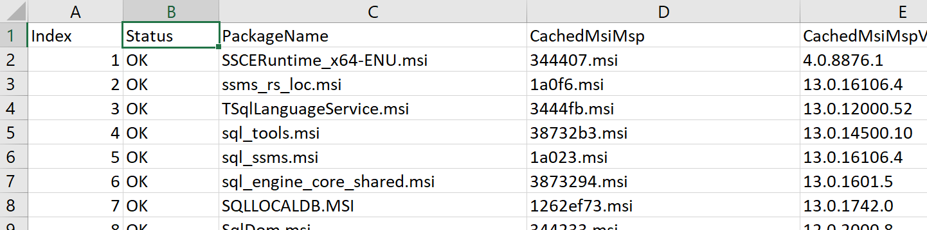

6.



Each column is sortable if you click it. And you can drag/drop the column header to change their order.

7.

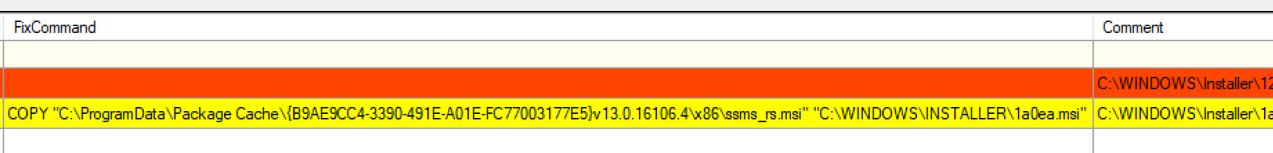

FixCommand is the command how to fix the missing/mismatched file.

Comment has more information about the command.

8.

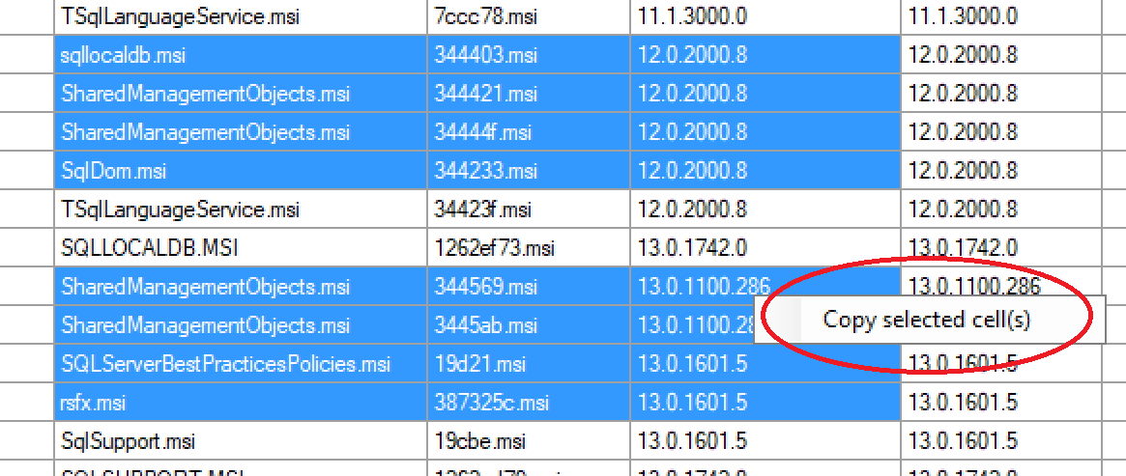

Right click the selected cells you can copy them to clipboard.

9. Find/Find Next

You can find something in the grid

